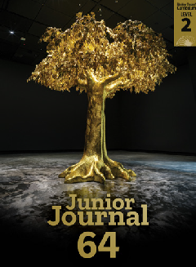
Tree Facts
by Sophie Fern
Junior Journal 64
Level 2
Gold 1

The Learning Progression Frameworks (LPFs) describe significant signposts in reading and writing as ākonga develop and apply their literacy knowledge and skills with increasing expertise from school entry to the end of year 10. This teacher support material describes the opportunities in “Tree Facts” for ākonga to develop this expertise.
Overview
This report builds on ideas introduced in “What Is a Tree?” and provides information about five New Zealand trees. The information is presented in the form of tables, giving ākonga experience in reading different text formats. It includes a tree identification quiz for ākonga to enjoy.
A PDF of this article and an audio version as an MP3 file are available at www.juniorjournal.tki.org.nz For information about related texts, see the TSM “All about Trees”.
LPFs | Curriculum links
- Making sense of text: using knowledge of text structure and  features  - Making sense of text: vocabulary knowledge  - Reading to organise ideas and information for learning  - Acquiring and using information and ideas in informational texts | - English  - Science: The Living World

Key text features
“Tree Facts” includes the following characteristics that help ākonga develop the reading behaviours expected at Gold and build their awareness of the features of non-fiction.
The New Zealand Curriculum

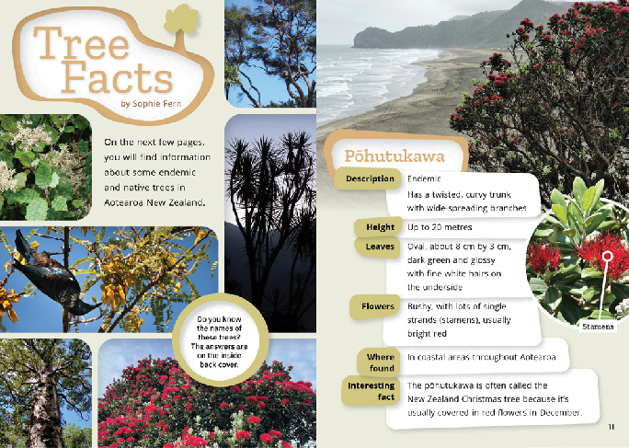

Language features typical of non-fiction, for example:
- definitions in parentheses
- precise descriptive language, including:
‒ noun phrases (“a twisted, curvy trunk”, “coastal areas”, “smooth grey bark”)
‒ subject-specific compound words and hyphenated words: (“wide-spreading”, “underside”, “bellbirds”, “blue-white”)
‒ measurements and qualifiers (“up to 20 metres”, “about
8 cm by 3 cm”, “usually”, “sometimes”, “often”) and “cm” as a shortened form of “centimetres”
‒ the suffix “let” in “leaflets” to indicate the small size of the leaves
‒ inverted commas for the term “bushman’s toilet paper”.
Some possibly unfamiliar topic-specific vocabulary (for example, “information”, “endemic”, “native”, “Description”, “twisted”, “curvy”, “wide-spreading”, “Height”, “metres”,
“oval”, “glossy”, “bushy”, “strands”, “stamens”, “usually”, “coastal areas”, “throughout”, “tangled”, “leaflets”, “nectar”, “rough”, “narrow”, “scented”, “wetlands”, “Early”, “prickly”,
“shrub”, “medicine”, “attract”, “scrub”, “settlers”, “imagine”) and tree names, all in te reo Māori and some also in English, requiring ākonga to apply their processing systems
Design features typical of non-fiction: headings, tables, photographs (including close-up images), captions
The use of notes rather than full sentences in the tables so that ākonga are required to attend to the table headings, punctuation, and linking words and phrases to track connections between ideas
The structure of the text as a report with an introduction followed by information in table form

The above spread:
Text copyright © Crown 2022
TEACHER SUPPORT MATERIAL FOR “TREE FACTS”, JUNIOR JOURNAL 64, 2022 1
Copyright © Crown 2022

Possible reading purposes | Possible learning goals
What can ākonga expect to find out or think about as a result of reading this text?  - To find information about some New Zealand trees  - To think about the similarities and differences between trees  - To think about how information can be presented in different ways. | What opportunities does this text provide for ākonga to learn more about how to “read, respond to, and think critically” about texts?  This text provides opportunities for ākonga, over several readings, to:  - make connections between the text and visual language features to track information  (summarise)  - visualise and compare information about the trees  - ask questions and look for or think about possible answers  - make connections between the information in this article and in “What Is a Tree?”  - monitor their reading and, when something is unclear, take action to solve the problem.

Sounds and Words
The Literacy Learning Progressions
Introducing the article

- It would be best for ākonga to have read and discussed “What Is a Tree?” first so they have some prior knowledge of the topic and key vocabulary.
- Read the title and clarify what “facts” are. Briefly recap some facts about trees from reading “What Is a Tree?” Use the opportunity
to draw out (or feed in) key topic vocabulary, such as “native”, “endemic”, and the names for parts of trees.
- Tell ākonga that you have an article for them to read that provides more detail about some New Zealand trees. Ākonga could attempt the tree identification activity on page 10.
- Together, read and discuss the information in the first table (page 11), making connections to what ākonga already know
about pōhutukawa. Draw attention to text features such as the headings in the left-hand column, the use of note form rather than full sentences for the information, and the precise descriptive language, including measurements.
- Look through the rest of the article to see what other trees are featured.
- Together, set a reading purpose and share the learning goal(s). Ākonga could start reading at this point or, if you feel they need more support, you could read another table together.
- Give ākonga sticky notes to mark questions or ideas that arise as they read or to note aspects they might want to return to or discuss later.

Reading the report
Encourage ākonga to read the report by themselves, intervening only if needed. The focus of the first reading is for ākonga to identify key information and ideas relevant to the initial reading purpose. (For examples of the sorts of reading behaviours to look for and support, see the TSM for “What Is a Tree?”) Allow for several sessions to read and discuss the text, to investigate other reading purposes, and explore ideas and language features more deeply.
Deliberate acts of teaching
How you can support individual ākonga (if needed).
- Prompt ākonga to draw on their phonics knowledge and other word-solving strategies, for example:
‒ when decoding:
» breaking words into chunks or syllables (“com-mon”, “branch-es”, “under-side”, “through-out”, “cover-ed”, “leaf-lets”)
» drawing on their knowledge of variations in the sounds of letters and letter combinations ( “Height”, “metres”, “usually”, “Kōwhai”, “grey”, “straight”, “rough”, “scented”, “medicine”, “imagine”)
‒ when working out the meaning of words and phrases:
» looking for definitions (including definitions in “What Is a Tree?)
» noticing punctuation, for example, commas to separate phrases and hyphens within the measurements
» using the photographs
» rereading or reading on to look for further information.
- Remind them to note things they are not sure about or that are of particular interest and remind them that you will discuss their questions and ideas after the reading.
- If necessary, provide specific support, for example, with the pronunciation of tree names or how to read the measurements.

Thinking, talking, rereading
- Encourage ākonga to share their responses to the article. Ask them to share an interesting fact about one of the trees or to say which of these trees is their favourite, and why.
- Enjoy finding the answers to the quiz activity. How did the information in the tree tables help you?
- Ask ākonga to share questions they thought of as they were reading. Discuss how they might find answers to questions not answered in the article and provide an opportunity for them to do this.
- Ask ākonga how they found reading information from the tables. Discuss the use of note form. Practise reading some examples together to model how to mentally fill in the missing words, for example: “[The pōhutukawa tree] has a twisted, curvy trunk …”, “[It grows] up to 20 metres [tall]”.
- Focus on the close-up images. What are these showing? How do they help?
- Return to the vocabulary chart created when reading “What Is a Tree?”. Add new topic words from “Tree Facts” and discuss their meanings, drawing on information in the text as well as other sources, such as a dictionary or the internet.
- Support ākonga to locate and use the information in the tables. They could track the headings across tables to compare the heights, the shape and look of the leaves and flowers, or where the trees are found.
Building language knowledge
As ākonga reread and discuss the text, note opportunities for explicit instruction and to explore language features in more detail. You could discuss:
- how ākonga worked out new vocabulary (or tried to). What helped you?
- the precise descriptive language, including:
‒ the words and phrases that describe the size of the trees and their leaves (for example, “wide-spreading”, “up to 20 metres”, “about 8 cm by 3 cm”, “small”, “tiny”, “taller”, “large”). Explain how to read the measurements (for example, “1–3 cm”, “0.5–2 cm”).
‒ the hyphenated or compound descriptive vocabulary (“wide-spreading”, “bellbirds”, “blue-white”, “underside”, “wetlands”, “lowland”, “bushman’s”)
‒ descriptive noun phrases, for example, “a twisted, curvy trunk”, “wide-spreading branches”, “ a small, prickly tree”. Discuss how the combination of words helps build a picture.
‒ the suffix “let” in “leaflets” to mean “small”. Explore other examples (“droplet”, “piglet”, “booklet”). You could also draw attention to the other meaning of leaflet (an information sheet).
  - During shared writing, use the information in one of the tables as a guideline for writing a short report about the tree. The headings provide a useful structure, and you can also model how to make the note form in the table into full sentences.
  - Ākonga could work individually or in pairs to find out more about one of the trees or another New Zealand tree, perhaps a tree that is significant in their local area. Alternatively, ākonga with connections to other countries might like to research a tree that is important to them and their whānau. Ākonga could record their findings in a table with the same headings as in the article or write a short report, as outlined above.
  - Write extracts from the descriptions of the trees, flowers, and leaves on cards and have ākonga use them for matching and sorting activities. You might go for a walk and use the cards to identify any of the trees you see, or ākonga could work in pairs with one asking a question (such as “Which trees are under 20 metres / have white flowers?) for the other to answer.
For further suggestions see the “What Is a Tree?” TSM.
For English language learners, SELLIPS and the Teaching Strategies section of ESOL Online also have ideas for purposeful and relevant tasks.

ISBN 978-1-77690-795-3 (PDF)
ISBN 978-1-77690-799-1 (WORD)

